Sprint 2 Report

Actions to Stop Doing
- Making decisions without consulting the team members responsible for that work.

Actions to Start Doing
- Commenting what a block is doing, input and output formats
- Naming variables to be more consistent and precise
- The team should move our Monday meeting time to 1:45 PM so we can spend an hour of dedicated group work time after our Scrum.

Actions to Keep Doing
- Working in independent branches
- Getting a second opinion before merging

Work Completed
- Location Autocomplete Story
- Additional Search Parameters Story
- Stories from Sprint 1

Work Not Completed
- Date Range Story

Work Completion Rate
- We completed 2/3 of the assigned stories for this sprint, and the remaining story is 80% completed
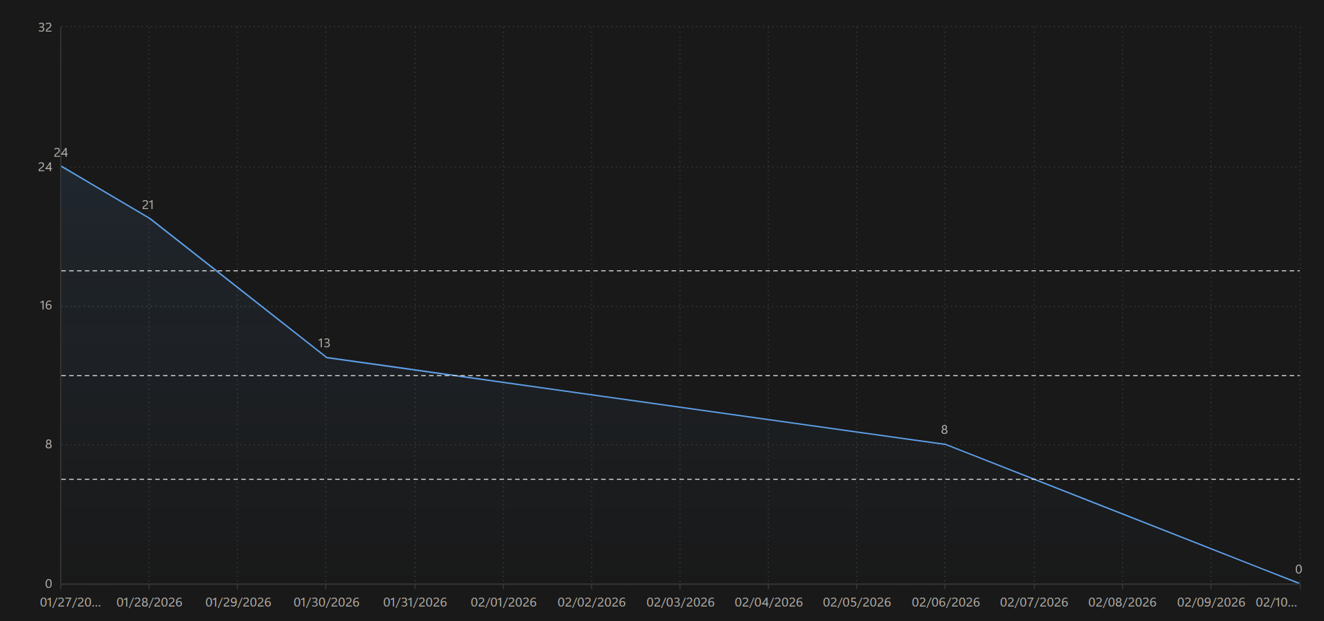
During this sprint, our team completed 10 user stories totaling 24 story points. The sprint duration was 14 days.

